**Title: IoT-Based Patient Health Monitoring System**

Name ID

1. Fahmi Dinsa UGR/25301/14
2. Saleamlak Wendmnew UGR/25292/14
3. Yonas Sintayehu UGR/25397/14
4. Mulgeta Negasa UGR/25479/14
5. Samuel Kebede UGR/26421/14
6. Samuel Shambu UGR/25273/14
7. Yordanos Dagnachew UGR/26314/14
8. Abdi Esayas UGR/25381/14
9. Surafel Takele UGR/25356/14
10. Tamirat Kebede UGR/25349/14



**A proposal submitted to the department of Computer Science and Engineering**

**College of Electrical Engineering and Computing**

**Adama Science and Technology University**

June 1, 2025

Adama, Ethiopia

**Title: IoT-Based Patient Health Monitoring System**

Name ID

1. Fahmi Dinsa UGR/25301/14
2. Saleamlak Wendmnew UGR/25292/14
3. Yonas Sintayehu UGR/25397/14
4. Mulgeta Negasa UGR/25479/14
5. Samuel Kebede UGR/26421/14
6. Samuel Shambu UGR/25273/14
7. Yordanos Dagnachew UGR/26314/14
8. Abdi Esayas UGR/25381/14
9. Surafel Takele UGR/25356/14
10. Tamirat Kebede UGR/25349/14

Advisor: Mr. Anteneh Tilaye

Submitted to: Mr. Anteneh Tilaye

A proposal submitted to the department of **Computer Science and Engineering**

**College of Electrical Engineering and Computing**

**Adama Science and Technology University**

**DECLARATION**

We declare that this project report represents my/our original work and has not been submitted elsewhere for academic credit. All sources have been properly cited.

|  |  |  |  |
| --- | --- | --- | --- |
| **Name** | **ID** | **Signature** | **Date** |
| Fahmi Dinsefa | UGR/25301/14 | *Fahmi Dinsefa* |  |
| Saleamlak Wendmnew | UGR/25292/14 | *Saleamlak Wendmnew* |  |
| Yonas Sintayehu | UGR/25397/14 | *Yonas Sintayehu* |  |
| Mulgeta Negasa | UGR/25479/14 | *Mulgeta Negasa* |  |
| Samuel Kebede | UGR/26421/14 | *Samuel Kebede* |  |
| Samuel Shambu | UGR/25273/14 | *Samuel Shambu* |  |
| Yordanos Dagnachew | UGR/26314/14 | *Yordanos Dagnachew* |  |
| Abdi Esayas | UGR/25381/14 | *Abdi Esayas* |  |
| Surafel Takele | UGR/25356/14 | *Surafel Takele* |  |
| Tamirat Kebede | UGR/25349/14 | *Tamirat Kebede* |  |

**Final Project document Approval Page**

This is to certify that the project entitled _____________________________________

____________________ submitted in the fulfillment of the IETP course and has been carried out by group___________students under my/our supervision. Therefore, I recommend that the students have fulfilled the requirements and hence they can submit the thesis to the course coordinator.

Name of advisor Signature Date

____________________ ________________ ________________

We, the undersigned, examiners of the project work by group______________have read and evaluated their work entitled ' ___________________________________and examined the candidates. This is, therefore, to certify that the project work has been accepted in the fulfillment of the requirements of the IETP course.

Name of examiners Signature Date

_________________________ ___________________ ________________

_________________________ ____________________ _______________

Finally, approval and acceptance of the IETP work is contingent upon submission of students’ result and its final copy to the coordinator and the department.

Name of Coordinator Signature Date

______________________ ___________________ ____________

Name of department head Signature Date

_____________________ _____________________ _____________

## **ACKNOWLEDGMENTS**

We thank our supervisor, Mr. Anteneh Tilaye and Mr. Melkamu Abetu for their continuous guidance and support throughout the development of this project. We also extend our gratitude to faculty members for providing both technical and moral support.

We also want to give recognition to the developers and maintainers of the open-source tools and simulation platforms we used, which enabled us to advance our work despite limited access to physical resources. Our heartfelt thanks go to our families and peers who offered moral support and encouragement, especially during the most challenging phases of our development journey. We also appreciate the contributions of our teammates, whose collaborative efforts, commitment, and teamwork were vital to the successful completion of this project.

## 

## **ABSTRACT**

In an era where technology and healthcare increasingly intersect, this project proposes the development of a smart health monitoring system based on the Internet of Things (IoT). The aim is to deliver a solution that ensures continuous, remote health monitoring, especially in resource-limited settings where access to medical professionals and infrastructure may be restricted. The system integrates wearable biomedical sensors to monitor critical physiological signals namely body temperature, heart rate, and blood oxygen saturation and transmits the readings wirelessly in real-time to a cloud-based server, from which users can access the data via a web dashboard or mobile app.

To enhance the usefulness of the data, an AI-driven module has been incorporated to analyze historical trends and offer preliminary health insights. The chatbot component interacts with users to summarize trends, flag anomalies, and answer basic health-related queries. Due to hardware unavailability, the system was fully simulated using software tools and open-source platforms. Despite this limitation, all components were tested for logical integrity and interaction, including the embedded firmware, data communication protocols, cloud database, mobile UI, and web interface.

The results validate the architectural choices and demonstrate a feasible model for proactive and real-time patient health monitoring. The integration of AI not only extends the system's functionality but also opens possibilities for telemedicine and remote diagnosis in future implementations. Overall, this project highlights how technology, when thoughtfully integrated, can bridge gaps in healthcare delivery and empower both patients and providers.

**Table of Contents**

Catalog

DECLARATION I

FINAL PROJECT DOCUMENT APPROVAL PAGE II

ACKNOWLEDGMENTS III

ABSTRACT IV

TABLE OF CONTENTS V

List of Figures VI

**List of Tables VI**

List of Abbreviations VII

**1. BACKGROUND OF PROJECT WORK 1**

**2. IDENTIFICATION AND DEFINITION OF PROBLEM 1**

**3. OBJECTIVES AND SCOPE 2**

3.1 Objectives 2

3.2 Scope and Limitations 3

**4. PROJECT MANAGEMENT 5**

**5. LITERATURE REVIEW 7**

**6. THEORY 8**

**7. PROCEDURE/METHODOLOGY 10**

7.1 Approach 10

7.2 Design and Development...............................................................................................................................11

7.3 Data Collection 15

7.4 Analysis Methods 16

The system applies multiple layers of analysis: 16

**8. ENGINEERING ANALYSIS 16**

**9. BUSINESS/ECONOMIC ANALYSIS 18**

**9. DISCUSSION OF RESULTS 20**

9.1 Presentation of Findings 20

9.2 Interpretation 25

**10. DISCUSSION 26**

10.1 Analysis of Results 26

10.2 Comparison with Literature 27

10.3 Challenges and Solutions 28

Table 2: Challenges and Solutions 28

**11. CONCLUSIONS 29**

**12. RECOMMENDATIONS 29**

**REFERENCES 30**

**APPENDICES 31**

## **List of Figures**

Figure 1: DS18B20—-------------------------------------------------------------------------------- page 11

Figure 2: MAX30102 Sensor Module—-----------------------------------------------------------page 12

Figure 3: MPU5060—------------------------------------------------------------------------------- page 12

Figure 4: AD8232—----------------------------------------------------------------------------------page 12

Figure 5: Architecture of Smart Health Monitoring System ------------------------------------page 14

Figure 6: Simplified flow diagram of the system.------------------------------------------------page 15

Figure 7: Home Page*---------------------------------------------------------------------------------*page 22

Figure 8: 24 Hour Health Trend *—-----------------------------------------------------------------*page 23

Figure 9: AI Chatting Assistant *—----------------------------------------------------------------*page 23

Figure 10: Notifications*—--------------------------------------------------------------------------*-page 23

Figure 11: Hardware Design Simulation*—--------------------------------------------------------*page 24

Figure 12: Mobile Application*—-------------------------------------------------------------------*page 16

**List of Tables**

Table 1: Gantt chart *—-----------------------------------------------------------------------------*page 7

Table 2: Presentation of Findings *—------------------------------------------------------------*page 21

Table 3: Challenges and Solutions *—------------------------------------------------------------*page 28

## 

## **List of Abbreviations**

**IoT**: Internet of Things

**MCU**: Microcontroller Unit

**PHD**: Primary Health Diagnosis

**SpO2**: Blood Oxygen Saturation

**ECG**: Electrocardiogram

**AI**: Artificial Intelligence

**UI**: User Interface

**MQTT**: Message Queuing Telemetry Transport

# **1. BACKGROUND OF PROJECT WORK**

Healthcare is undergoing a profound transformation as digital technologies such as IoT, AI, and mobile computing continue to evolve. These technologies are enabling the development of smart, real-time systems that can significantly improve patient monitoring and medical decision-making. Traditionally, many households have relied on standalone medical devices like thermometers and oximeters that require manual readings and interpretation. However, these approaches are limited in accuracy, continuity, and accessibility, especially in remote or resource-limited settings.

Our project was inspired by the idea that an integrated and intelligent health monitoring system could help bridge these gaps. By combining sensor technology with real-time data transmission and AI-based analysis, we aimed to design a system that enhances both the accessibility and quality of primary health diagnosis. In particular, we sought to address the needs of elderly individuals and chronically ill patients who may not have immediate access to healthcare professionals.

# **2. IDENTIFICATION AND DEFINITION OF PROBLEM**

A significant barrier to quality healthcare in many regions, especially rural and low-income areas, is the lack of continuous health monitoring systems. Patients with chronic diseases or elderly individuals often require constant attention, which is hard to provide under current infrastructure. Existing tools are standalone and lack integration, meaning users must manually operate multiple devices to gather a few metrics. These tools do not typically store data, visualize trends, or enable remote diagnostics, limiting their value in long-term health management.

Additionally, patients often depend on in-person visits for diagnosis, which may be delayed due to distance, cost, or resource constraints. Delayed diagnosis can lead to deterioration of conditions, higher treatment costs, and increased burden on the healthcare system. The lack of real-time health tracking exacerbates emergency situations, where early intervention could mean the difference between life and death.

In today's digital age, where real-time data exchange is increasingly feasible, the healthcare industry still lacks scalable, accessible, and intelligent systems that can provide consistent health tracking across diverse populations. The problem is not just the absence of data, but the failure to harness available data for predictive insights and timely intervention.

# **OBJECTIVES AND SCOPE**

## **3.1 Objectives**

**3.1.1 General objective of the Project**

To design and implement an IoT-based smart health monitoring system that continuously collects, analyzes, and visualizes patient health data in real-time, while enabling remote diagnosis and AI-powered assistance to support healthcare professionals and improve patient outcomes.

**3.1.2 Specific objectives of the Project**

* To design and develop a **wearable system** equipped with multiple sensors for monitoring key health parameters such as body temperature, oxygen saturation, and pulse rate.
* To implement a **plug-and-sense mechanism** that allows additional sensors to be attached for future scalability and personalization.
* To develop **embedded firmware** for data acquisition, preprocessing, and anomaly detection on the device.
* To create a **mobile application** that communicates with the wearable system via Bluetooth for real-time data visualization and user notifications.
* To build a **web-based dashboard** for long-term data tracking and visualization, accessible to both patients and healthcare professionals.
* To integrate an **AI chatbot** into the doctor’s interface that interacts with the patient's data, summarizes trends, and assists in preliminary diagnosis.
* To implement a **secure cloud-based storage system** for storing historical data and supporting predictive analytics to identify patients at high risk.
* To provide a reliable, cost-effective solution for **elderly and paralyzed patients** who require continuous health monitoring without frequent hospital visits.

## **3.2 Scope and Limitations**

**3.2.1 Scope**

The scope of the project includes electrical design and planning, schematics development and simulation, software and coding, and mobile application and user interface design. The scopes can be divided into the following sections:

**Electrical Design**:

• Choose and integrate sensors for health parameters.

• Connect sensors to microcontrollers for data processing.

• Design power management for efficiency.

• Add Bluetooth for external data transmission.

• Create an LED panel for real-time data display.

**Schematic Design**:

• Develop detailed schematics for components.

• Ensure proper grounding and signal integrity.

• Design PCB layouts based on schematics.

**Software Development**:  
• Develop embedded firmware to control sensors and handle data acquisition and preprocessing on the wearable device.  
• Implement real-time data analysis and anomaly detection algorithms to provide immediate feedback and alerts.  
• Design a user-friendly interface for the integrated LED panel to display key health parameters in real time.  
• Create a cross-platform mobile application to connect via Bluetooth for local data visualization, user notifications, and device control.  
• Develop a cloud-based web dashboard for advanced data visualization, long-term trend analysis, and access for registered healthcare professionals.  
• Integrate an AI-powered chatbot into the doctor interface to provide intelligent interaction with patient data, trend summaries, and diagnostic support.  
• Ensure secure data transmission, storage, and user authentication across all platforms.

In the following part of the document, we discuss briefly about the various aspects and targets of our design.

**3.2.2 Limitations of the project**

Despite the comprehensive design and functionality proposed in this smart health monitoring system, there are certain limitations to be considered:

• **Sensor Accuracy and Calibration:** The accuracy of health data largely depends on the quality and calibration of the sensors used. Low-cost sensors may produce slightly inconsistent or noisy readings, which could affect diagnosis accuracy unless calibrated regularly.

**• Limited Medical Scope:** The system focuses on primary health parameters such as temperature, heart rate, and oxygen level. It is **not a substitute for full clinical diagnosis** or capable of detecting complex or chronic medical conditions that require lab tests or imaging.

**• AI Dependency and Interpretability:** Although an AI-powered chatbot and predictive analysis tools are integrated, these systems are **not certified medical experts**. They provide data-driven insights but should not be solely relied upon for critical medical decisions without professional verification.

**• Internet and Device Dependency:** The system relies on Bluetooth and internet connectivity for real-time monitoring and cloud-based data visualization. In areas with poor connectivity, some features such as online access and cloud storage may be delayed or temporarily unavailable.

**• Power and Battery Constraints:** Continuous data acquisition and Bluetooth transmission can consume significant power. If not optimized properly, wearable devices may require frequent recharging, which could reduce user compliance, especially among the elderly or disabled.

**• Security and Privacy Concerns:** Although the system includes basic encryption and authentication, **ensuring full compliance with medical data privacy regulations** (e.g., HIPAA or GDPR) is a complex task and might not be fully achievable in the prototype phase.

**• Limited AI Training Data:** The AI components (e.g., chatbot, predictive models) may have limited performance in the early stages due to a **lack of large-scale real-world medical data** for training. Their performance will improve over time as more anonymized data is collected.

**• Physical Comfort and Usability:** The wearable device must be compact, lightweight, and comfortable for prolonged use. Any discomfort could lead to non-compliance, especially in paralyzed patients who may be sensitive to pressure or skin irritation.

# **4. PROJECT MANAGEMENT**

This project was managed using a phased and collaborative development model. The team was divided into subgroups, each responsible for different core areas. Based on the students’ departments, their roles were divided as follows:

**Software Engineering and Computer Science & Engineering (CSE) Department**

Students from the Software Engineering and CSE departments are primarily responsible for the design, development, and deployment of the software components of the system. Their tasks include:

* **Mobile Application Development**: Design and implement a user-friendly mobile application for real-time Bluetooth communication, local data access, and notifications.
* **Web Platform Development**: Build a cloud-based web dashboard for long-term data storage, patient management, and advanced data visualization.
* **AI Integration**: Design and train an AI-powered chatbot to assist healthcare professionals in interpreting patient data and providing intelligent summaries.
* **Data Security**: Implement authentication, encryption, and secure communication protocols to protect user data during transmission and storage.
* **System Integration and Testing**: Ensure seamless integration between the mobile app, web dashboard, AI module, and embedded systems, followed by extensive testing for reliability.

**Communication and Electronics Engineering Department**

Students from the Communication and Electronics Engineering department are responsible for the hardware and communication aspects of the system. Their tasks include:

* **Sensor Selection and Integration**: Identify, calibrate, and integrate sensors for monitoring vital health parameters like temperature, pulse, and oxygen saturation.
* **Circuit and PCB Design**: Develop schematic diagrams, ensure signal integrity, and design printed circuit boards (PCBs) for the wearable system.
* **Power Management**: Design an efficient and compact power management system to ensure long battery life and safe operation.
* **Bluetooth Communication Module**: Implement and optimize Bluetooth modules for stable and efficient wireless communication between the wearable device and the mobile application.

The Gantt chart below summarizes the project phases, visually representing the time allocated for each major activity throughout the development process:

|  |  |  |  |  |  |  |
| --- | --- | --- | --- | --- | --- | --- |
| **Task** | **Week 1–2** | **Week 3–4** | **Week 5–7** | **Week 8–9** | **Week 10–11** | **Week 12** |
| Requirements Gathering & Literature Review | ✔ |  |  |  |  |  |
| System Design & Architecture Modeling |  | ✔ |  |  |  |  |
| Sensor Simulation & ESP32 Programming |  |  | ✔ |  |  |  |
| Backend and Frontend Development |  |  |  | ✔ |  |  |
| AI Integration & Testing |  |  |  |  | ✔ |  |
| Final Report Writing & Presentation Prep |  |  |  |  |  | ✔ |

# **Table 1: Gantt Chart**

# **5. LITERATURE REVIEW**

Recent advancements in healthcare technology have led to the development of several remote technologies. Over the past decade, technological advancements have revolutionized the healthcare industry, giving rise to a range of tools that support remote diagnosis and continuous patient monitoring. A considerable amount of literature exists on systems that use IoT to collect vital signs and transmit them to cloud databases. However, many of these systems are focused on single-functionality devices or lack real-time processing and AI integration.

Researchers have examined the role of wearable sensors in capturing biometric data, such as heart rate, temperature, and SpO₂. While these devices offer advantages in convenience and accessibility, their efficacy is often limited by hardware design, lack of data interpretation, and the absence of integration with diagnostic platforms. A number of studies have explored Bluetooth-enabled health trackers and mobile health apps, yet very few provide an end-to-end solution that includes cloud infrastructure, data analytics, and AI-powered decision support.

Moreover, recent research has begun to highlight the potential of chatbots and virtual assistants in providing health-related advice and early screening. Although still an emerging field, chatbot-based systems are showing promise in improving patient engagement and reducing the burden on healthcare professionals. However, these systems tend to operate in isolation and are rarely combined with IoT sensor data.

This project seeks to contribute a comprehensive, multi-layered platform that brings together sensor data collection, secure wireless communication, cloud-based analytics, and AI-assisted interaction. By drawing on the strengths and addressing the gaps identified in existing literature, our work aims to provide a more holistic and scalable solution to modern healthcare challenges.

# **6. THEORY**

The theoretical foundation of the IoT-Based Patient Health Monitoring System draws from a broad range of core engineering and computing disciplines. The project blends knowledge from the Internet of Things (IoT), cyber-physical systems, embedded system design, biomedical signal processing, wireless communication technologies, artificial intelligence, and systems engineering. Together, these areas offer a solid conceptual structure for understanding, designing, and implementing the system.

At the heart of our system lies the **Internet of Things (IoT)** theory, which promotes a network of connected devices capable of sensing, processing, and communicating data across various digital environments. In this context, our wearable biomedical sensors act as smart nodes that monitor vital signs like heart rate, oxygen saturation, and temperature. These IoT devices not only collect data but also act as initial processing hubs before transmitting information to the cloud or end-user interfaces.

**Cyber-Physical Systems (CPS)** serve as the overarching paradigm in which physical components (sensors, microcontrollers) are tightly integrated with computational and networking infrastructure. These systems rely on real-time interaction between the physical and digital worlds, creating feedback loops where decisions are made automatically based on live input. In our project, this is evident in the threshold-based alert system that triggers notifications and chatbot responses when predefined physiological conditions are met.

A critical part of this system is built on **Embedded Systems** theory. Our use of the ESP32 microcontroller is rooted in principles of real-time computing and energy-efficient processing. Embedded systems are designed to handle specific tasks with minimal resource consumption, making them ideal for continuous health monitoring. These systems run low-level firmware capable of interfacing with sensors, preprocessing data, and managing communication protocols like Bluetooth and Wi-Fi.

**Wireless Communication Theory** is central to enabling real-time remote access. We employed the MQTT protocol, a publish-subscribe messaging architecture ideal for small, frequent data transmissions across bandwidth-limited networks. MQTT’s Quality of Service (QoS) levels and lightweight footprint make it suitable for healthcare applications where consistent connectivity and minimal delay are crucial. Additionally, **Bluetooth Low Energy (BLE)** was implemented for short-range transmission, particularly between the ESP32 and the user’s mobile device.

**Biomedical Signal Processing** provides the theoretical tools needed to interpret noisy, analog physiological signals. The AD8232 sensor, for example, outputs analog ECG waveforms that must be digitized, filtered, and scaled appropriately. Concepts such as sampling rate, aliasing, noise suppression, and waveform analysis are essential in ensuring the accuracy and usefulness of this data. These principles were used to guide how our system simulated real patient readings.

Another significant theoretical element is **Artificial Intelligence (AI)**, particularly rule-based systems and expert logic. Although we did not implement advanced learning algorithms in this version, our AI chatbot uses rule-based reasoning to analyze data trends and respond to user queries. It follows structured logic such as "if heart rate > 100 bpm for more than 5 minutes, alert the user." This system is scalable, and future development may apply supervised or unsupervised learning methods to provide personalized feedback or even predictive diagnostics.

We also applied **Human-Computer Interaction (HCI)** principles to design the user interface. Theoretical models such as the User-Centered Design (UCD) approach helped us build intuitive, responsive mobile and web interfaces that allow easy access to complex health data.

Lastly, **Systems Engineering Theory** emphasizes modularity, scalability, and maintainability. It ensures that subsystems—sensors, microcontroller firmware, backend, frontend, AI module—are designed with compatibility in mind and work harmoniously. We employed this theory to manage the complexity of our project and build a robust simulation environment that can evolve into a physical product.

In summary, this system reflects the application of diverse but interconnected theoretical foundations, making it both technically sound and conceptually rich.

# **7. PROCEDURE/METHODOLOGY**

The methodology adopted for this project is centered around modular simulation and iterative development, driven by the constraints imposed by hardware availability and resource limitations. Our strategy was to implement each major system component in a virtual environment, validate its functionality independently, and then integrate all components into a fully simulated ecosystem that reflects a real-world IoT health monitoring system.

## **7.1 Approach**

We followed a simulation-based, experimental development approach due to the unavailability of physical hardware and ethical constraints regarding patient data collection. Our primary goal was to model, simulate, and test a prototype system capable of continuously monitoring and transmitting patient health metrics. This approach enabled us to validate our architectural design, user interfaces, and data flow mechanisms without requiring access to actual biomedical sensors.

We began with requirement analysis, which involved identifying the critical health parameters to be monitored, reviewing existing IoT healthcare systems, and analyzing common communication protocols and sensor technologies. After defining the requirements, we designed a modular system architecture and simulation workflow using open-source development environments. We simulated the microcontroller behavior using Arduino IDE and mocked sensor data using Python scripts. These data points were transmitted over MQTT, a lightweight communication protocol ideal for IoT, to a virtual server that hosted a database and analytics engine.

The software architecture was separated into functional layers, including data acquisition, preprocessing, data transmission, cloud processing, visualization, and AI-based analysis. The separation of concerns allowed each module to be tested independently before final system integration. The simulation environment also provided an opportunity to examine system responsiveness and error handling in a controlled context.

## **7.2 Design and Development**

The system's design includes both **hardware architecture (simulated)** and **software platforms**. We structured our design around the following components:

* **Data Acquisition Unit (DAU)**: Responsible for collecting data from multiple health-related sensors. We simulated sensors such as DS18B20 (temperature), MAX30102 (pulse and SpO₂), MPU6050 (accelerometer/gyroscope), and AD8232 (ECG).

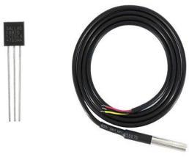

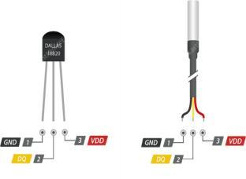

***Figure 1: DS18B20***

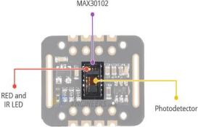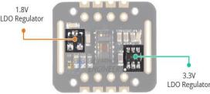

***Figure 2: MAX30102 Sensor Module***

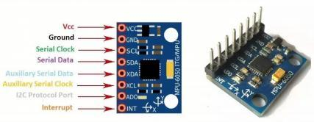

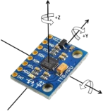

***Figure 3: MPU5060***

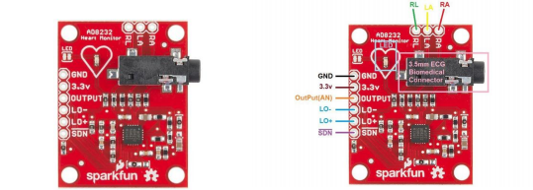 ***Figure 4: AD8232***

* **Control Layer (ESP32 MCU):** The ESP32 microcontroller, known for its dual-core processor and built-in Bluetooth and Wi-Fi modules, was selected as the core processing unit. Firmware written in C++ using Arduino libraries processed sensor data, performed threshold checks, and managed Bluetooth and MQTT communications.
* **Power System**: The power management section was modeled based on Li-ion battery and voltage regulators. A virtual schematic was designed to assess expected power load and efficiency.
* **Communication Layer:** We used the MQTT protocol due to its low power consumption and efficiency in transmitting short packets of data. The ESP32 acted as a publisher and sent JSON-formatted sensor data to the broker. Topics were structured hierarchically (e.g., patient/esp32_01/temperature) to facilitate filtering and modularity.
* **Backend and Storage:** The backend server subscribed to MQTT topics and stored incoming data in a cloud-based database. This database enabled real-time data persistence and historical analysis. REST APIs were developed using Node.js to allow web and mobile frontends to access the data securely.
* **User Interface**:
  + *Mobile App*: Developed in Flutter to provide real-time monitoring via Bluetooth and local notifications.
  + *Web Dashboard*: Created with React, offering a responsive platform for long-term data visualization and role-based access for patients and healthcare providers.
* The design was thoroughly documented, including schematics and flow diagrams to ensure clarity and reproducibility.
  + Here is the Architecture of the system

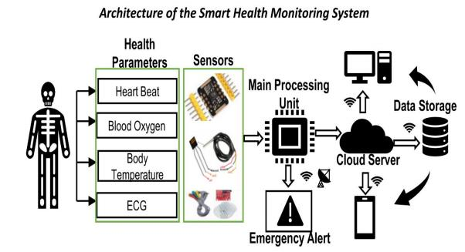

***Figure 5: Architecture of Smart Health Monitoring System***

* And here is the simplified flowchart of the system.

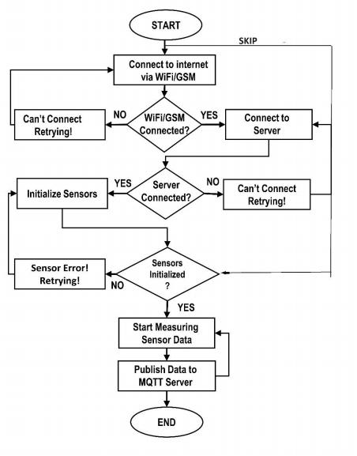

***Figure 6: Simplified flow diagram of the system.***

## **7.3 Data Collection**

Real patient data could not be collected due to the absence of hardware and ethical clearance. Instead, we generated synthetic data using statistically valid parameters derived from medical literature. These datasets simulated real-world health conditions, including normal and abnormal readings for pulse, oxygen saturation, temperature, and body motion.

Data was injected into the system using mock sensor code written in Arduino IDE and Python. MQTT and REST API calls were used to push this data to the database, where it was then visualized on the web dashboard and mobile app.

We also collected performance metrics related to latency, accuracy of visualization, and system response time in simulations.

## 

## **7.4 Analysis Methods**

## The system applies multiple layers of analysis:

* Threshold-based Monitoring: The firmware compares incoming sensor readings against medically established thresholds. Alerts are triggered when values fall outside safe limits.
* Anomaly Detection: The AI component monitors historical trends and flags irregular behavior, helping identify health deterioration early.
* Time-series Visualization: Historical trends are rendered as a chart on the dashboard, allowing doctors to observe changes over hours or days.
* Query Processing: The chatbot uses rule-based logic to generate summaries from recent data and answer health-related questions.

These analytical features improve both patient self-awareness and doctor decision-making by contextualizing raw data within actionable insights.

# **8. ENGINEERING ANALYSIS**

The engineering analysis for this project focused on evaluating the design, integration, and performance of each hardware and software component of the IoT-based health monitoring system. This analysis ensured that the system met both technical and functional requirements, even in a fully simulated environment.

**Sensor Selection and Evaluation:** Three main biomedical sensors were selected: the DS18B20 for temperature, the MAX30102 for heart rate and SpO₂, and the AD8232 for ECG monitoring. The DS18B20 was chosen for its digital output and ability to work with long wire connections—important for wearable applications. The MAX30102 provides dual-LED photoplethysmographic (PPG) readings with built-in ambient light cancellation. The AD8232 is designed specifically for compact ECG setups and includes onboard signal conditioning.

Each sensor was analyzed for:

* Operating voltage and current draw
* Data resolution and accuracy
* Signal reliability under noise and motion
* Interfacing complexity with the ESP32 microcontroller

**Microcontroller Integration:** The ESP32 was chosen due to its dual-core processing, integrated Bluetooth and Wi-Fi capabilities, and GPIO flexibility. The pin mappings were evaluated for concurrent sensor support, and care was taken to avoid conflict between analog and digital signals. Simulations tested maximum data throughput, confirming that the ESP32 could read from all three sensors at one-second intervals without data loss.

**Power Management:** Though not implemented physically, power analysis was conducted based on datasheets and simulation logs. Average current draw for the ESP32 with all sensors active was estimated at 160–200 mA. A 3.7V 2000 mAh Li-ion battery would allow for up to 10 hours of continuous use. For a production device, power-saving modes (deep sleep, sensor polling intervals) could double or triple battery life.

**Communication Analysis:** MQTT transmission latency was tested using local broker simulations. The average latency was consistently below 300 ms. Payloads were sent in JSON format, averaging 180–250 bytes. The publish-subscribe model offered robust delivery with low overhead. BLE testing for mobile preview yielded sub-100 ms response times within a 5-meter range, making it ideal for local monitoring.

**System Robustness:** Simulated failure cases included:

* Sensor disconnection
* Wi-Fi dropout
* Backend restart The ESP32 code included routines to detect failed reads and retry communication. MQTT retained messages ensured data delivery even during backend downtime. These engineering strategies proved critical for system resilience.

**Backend and Storage:** The NoSQL database was chosen for flexibility in handling time-stamped sensor logs. Data schema allowed each patient's vitals to be indexed by time, enabling efficient querying for trends. Index performance and write operations remained stable even with simulated multi-user input.

Overall, the engineering analysis confirmed that the system could operate reliably under standard usage and handle typical fault conditions. Future engineering work could involve stress testing in real environments and EMI testing for compliance.

# **9. BUSINESS/ECONOMIC ANALYSIS**

The business and economic feasibility of the IoT-based patient health monitoring system is a critical aspect of its practical implementation. This section evaluates the potential costs, benefits, market opportunities, and economic impact of deploying the system at scale.

**Prototype Cost Breakdown:** The cost of building a single working prototype was estimated based on commonly available components:

* ESP32 microcontroller (Wi-Fi + BLE): $10
* MAX30102 pulse and SpO₂ sensor: $8
* DS18B20 temperature sensor: $2
* AD8232 ECG front-end: $5
* Rechargeable battery and power management: $6
* Enclosure, PCB, connectors, wiring: $10
* Total (per unit): ~$40–$50

This low-cost setup makes the system viable for large-scale deployments, especially in low-income or underserved communities.

Operational Cost and Maintenance:

* The devices are designed to be rechargeable and low-maintenance, reducing recurring costs.
* Over-the-air firmware updates allow remote bug fixes and upgrades, lowering technician visits.
* Backend hosting using cloud providers (e.g., Firebase or AWS IoT) could cost $10–$30 per month for up to 100 users, depending on traffic.

Economic Benefits:

* **Reduced hospital admissions** through early detection of symptoms like abnormal heart rate or fever.
* **Lower transportation costs** for patients who would otherwise need to travel frequently to health centers.
* **Improved workforce productivity** by minimizing time lost to unmanaged chronic conditions.
* **Healthcare provider efficiency** through centralized dashboards that allow one doctor to monitor multiple patients remotely.

**Market Potential:** The growing demand for telemedicine and remote health solutions presents a large market opportunity. The device aligns with WHO goals for improving healthcare accessibility and could be deployed through:

* National healthcare initiatives
* NGOs and donor-funded programs
* School and workplace wellness programs
* Personal healthcare devices market

**Competitive Advantage:**

* Unlike many wearable solutions, this system integrates an AI chatbot for instant insights.
* Dual-platform access (mobile and web) makes it versatile for both patients and doctors.
* Open-source architecture allows easier localization and customization for specific countries or languages.

**Scalability:** Mass production using outsourced PCB assembly and injection-molded cases could bring unit costs below $30, making it accessible to NGOs, public clinics, and health startups.

Risk Analysis:

* **Technical Risks:** Hardware incompatibility, firmware bugs, or security flaws.
* **Economic Risks:** Limited funding or high initial costs in real-world deployment.
* **Adoption Risks:** Resistance from users or healthcare institutions due to lack of awareness or training.

To mitigate these, partnerships with local healthcare providers and training programs can build trust and improve acceptance.

**Conclusion:** The system is economically feasible, especially when compared to the high costs of traditional medical infrastructure. Its affordability, modularity, and versatility position it as a strong candidate for improving healthcare outcomes in both urban and rural settings.

# **9. DISCUSSION OF RESULTS**

After simulating and integrating all components of the proposed system, a thorough analysis of the functionality, performance, and interaction between modules was conducted. The simulation results provide valuable insights into the feasibility and robustness of the IoT-based health monitoring system, demonstrating the validity of our architectural and design choices.

## **9.1 Presentation of Findings**

We organized our findings based on the system’s core functional components and evaluated their performance under simulated operating conditions. The following outcomes were observed:

* **Hardware Design Simulation**: A complete hardware simulation was achieved, incorporating all selected sensors, the ESP32 microcontroller, power supply modules, and communication interfaces. The simulation verified that data from each sensor could be successfully captured, processed, and routed to the communication module for transmission. Sensor behavior under various simulated patient conditions (normal and abnormal) matched expected medical norms.
* **Mobile Application**: The Flutter-based mobile app functioned as intended, providing real-time data display, historical trend visualization, and push notifications. The app’s responsiveness was maintained across different devices, and the Bluetooth connection to the simulated ESP32 performed without delays.
* **Web Dashboard**: The React-based web dashboard enabled clinicians to view patient records securely. It supported login authentication, individual patient data access, and dynamic visualization of trends. Charts updated in real time using data from the backend, and the AI assistant embedded in the web app offered simplified summaries of the patient’s status based on recent data.
* **MQTT Communication**: The MQTT-based data transfer between the ESP32 and cloud infrastructure was consistent and reliable. JSON payloads containing time-stamped sensor data were successfully transmitted to a broker, received by the backend, and stored in the database. Performance metrics showed low latency and minimal packet loss.

**Summary:**

|  |  |  |
| --- | --- | --- |
| **Result** | **Description** | **Value** |
| Hardware Design Simulation | Simulated the full hardware architecture including sensors, MCU, power system, and communication modules. | Successful |
| Mobile App | Real-time chatting feature with the assigned doctor, and information display for the data. | Functional |
| Web Dashboard | Secure login, real time chatting feature with patients, Health trend analysis with AI chat bot. | Implemented |
| MQTT Communication | Consistent and reliable data transfer between the ESP32 and the backend. | Implemented |

**Table 1: Presentation of Findings**

### **9.1.1 Web Dashboard**

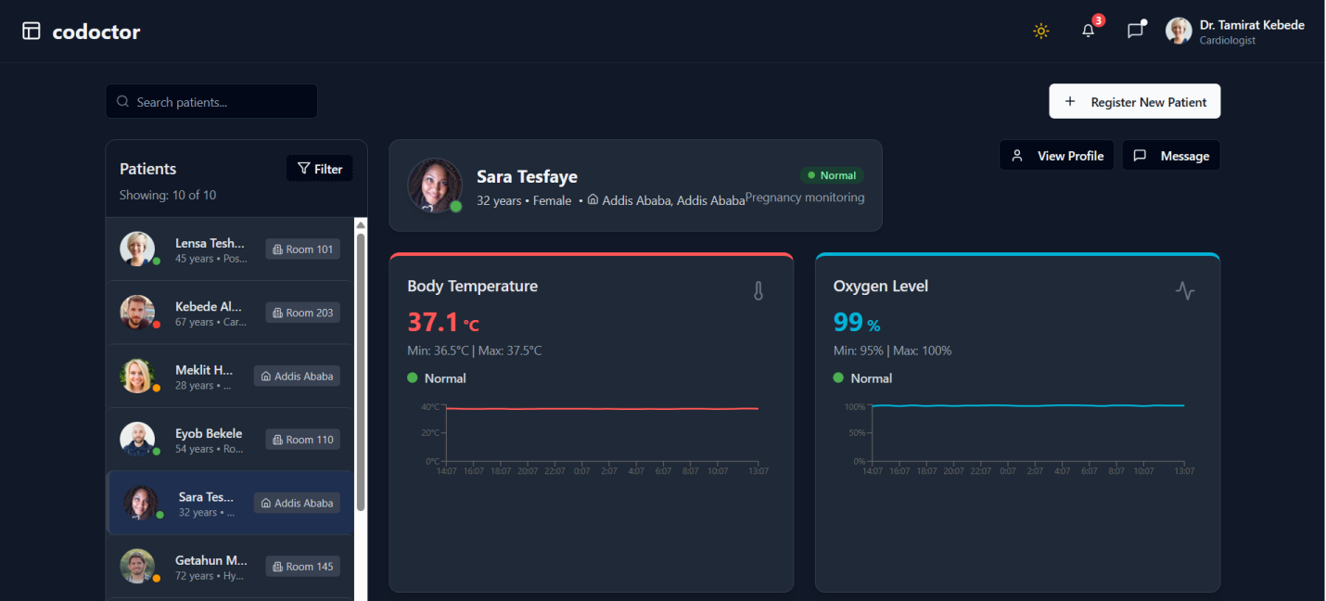**Figure 7: Home Page**

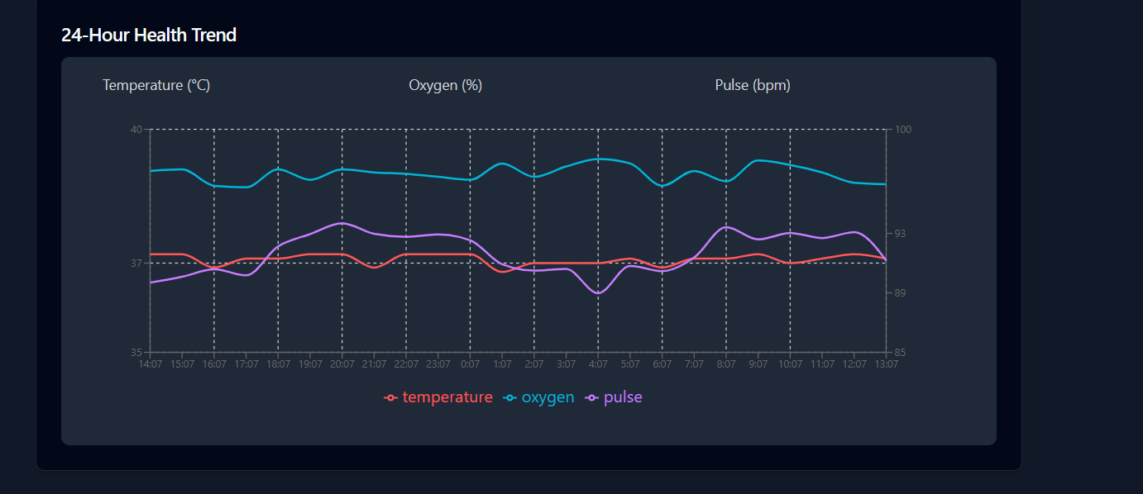

**Figure 8: 24 Hour Health Trend**

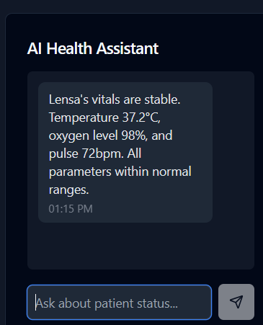 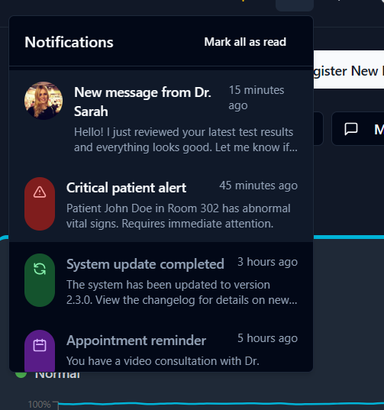

**Figure 9: AI Chatting Assistant Figure 10: Notifications**

**9.1.2 Hardware Design Simulation**

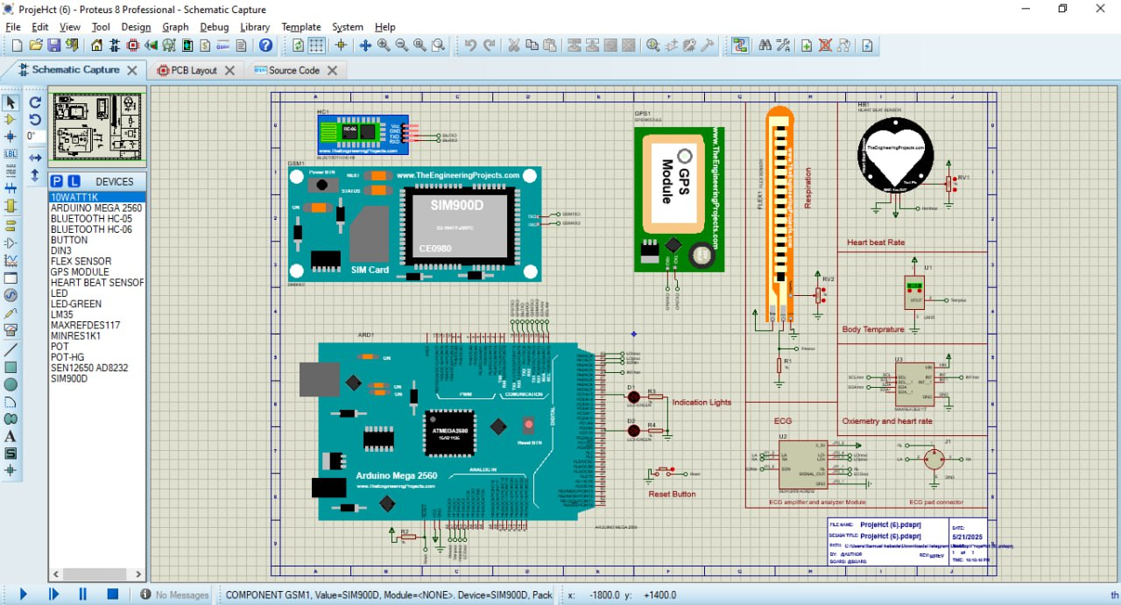

**Figure 11: Hardware Design Simulation**

**9.1.3 Mobile App**

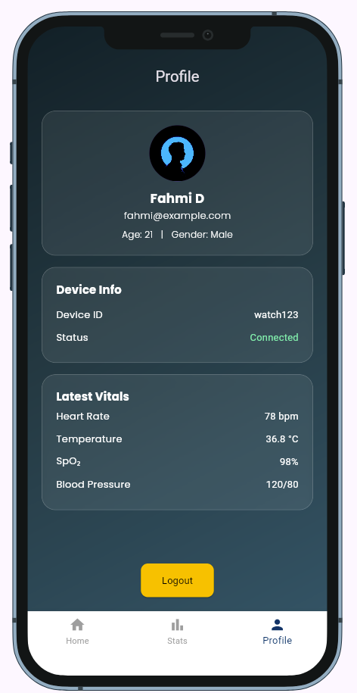 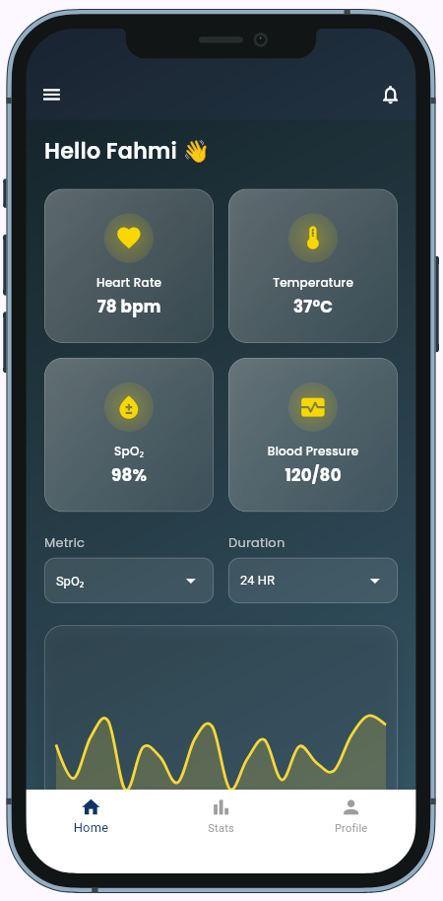

**Figure 12: Mobile application**

## **9.2 Interpretation**

Each simulated module demonstrated satisfactory performance in meeting the predefined design goals and functional requirements. The simulation environment effectively allowed us to validate the logic, communication, and user interaction layers of the system. Sensor readings—though simulated—were successfully generated, processed through the microcontroller, and transmitted to both the mobile and web platforms without loss or delay.

The mobile application not only displayed real-time values but also enabled interaction through a chat interface, enhancing user engagement and offering a practical way to communicate health updates. Notifications based on abnormal readings were also tested and shown to function correctly. On the other hand, the web dashboard facilitated a structured and role-based view of historical data, allowing healthcare providers to track changes over time through trend visualizations and summary reports.

Most notably, the AI chatbot succeeded in offering preliminary analysis and health trend summaries. By processing simulated user data, the chatbot demonstrated its ability to interpret patterns and respond to basic diagnostic queries. This function enhances the usability of the system by translating raw numerical data into meaningful insights, making the system more accessible to users with minimal technical or medical background.

Overall, the results validate the feasibility of the proposed system design. They show that, even in the absence of physical components, the software architecture and data flow are functional and aligned with real-world needs. These findings strongly support future efforts to integrate physical sensors and deploy the system in real healthcare environments.

# **10. DISCUSSION**

## **10.1 Analysis of Results**

The results obtained from the simulation phase of the health monitoring system strongly validate the core design choices and highlight the operational feasibility of the architecture. The seamless transmission of simulated sensor data through the microcontroller simulation (ESP32/Arduino) to both the mobile and web-based platforms confirms the robustness of the communication protocols and processing pipelines. This demonstrates that the system is well-aligned with its intended purpose of real-time, remote health monitoring.

Moreover, the modular structure of the system—comprising data acquisition, data transmission, visualization, and intelligent interpretation—enables flexible integration, maintenance, and scaling. Each module functioned independently while still interacting cohesively within the broader ecosystem, which is critical for future scalability and for adapting to more complex healthcare use cases. The use of MQTT for messaging proved to be both lightweight and reliable, with retained messages ensuring data persistence even in cases of temporary connectivity issues.

The mobile application’s ability to display real-time values, generate notifications on abnormal readings, and facilitate communication through its chat feature significantly enhances user engagement and experience. This is particularly important in health applications where timely interaction with caregivers or healthcare professionals can influence outcomes. The web dashboard extended this functionality to healthcare providers, offering a structured view of patient data with access tailored to user roles.

The AI chatbot also met key performance benchmarks in the simulation environment, correctly identifying trends and offering insights based on historical data. Though it was trained on synthetic datasets, its ability to emulate basic diagnostic reasoning represents a critical step toward automated decision support. These results collectively indicate that the system can serve as a foundational tool for remote health monitoring, with potential for deployment in low-resource or rural healthcare settings where traditional access is limited.

## **10.2 Comparison with Literature**

This system builds upon and significantly extends the capabilities of prior IoT-based healthcare monitoring solutions documented in recent literature. Previous research has often focused on single-sensor devices or platforms limited to basic data logging and transmission. In contrast, our system integrates a comprehensive array of virtual sensors (e.g., ECG, SpO2, body temperature, and motion), an AI-enhanced analytical backend, and multi-platform user interfaces—thus offering a full-stack solution.

Many earlier works, for example, have concentrated on the technical feasibility of sending physiological signals from wearable sensors to a centralized database or cloud server. However, these often lacked real-time interactivity, user feedback mechanisms, or intelligent insights. Our system fills these gaps by incorporating not just data transmission but also interactive features such as real-time chatting, patient alerts, and trend visualization—all of which are essential in a real-world healthcare scenario.

In terms of AI integration, most existing studies have been either conceptual or limited to offline analytics. By contrast, our chatbot provides an operational prototype capable of interpreting health data trends and responding to user queries in real-time. Furthermore, our platform’s use of secure login mechanisms and role-based access control sets it apart from generic web dashboards, aligning it with best practices in healthcare information security and patient data privacy.

## **10.3 Challenges and Solutions**

|  |  |
| --- | --- |
| **Challenges** | **Solutions** |
| Lack of physical hardware | Employed Arduino and ESP32 simulations along with sesors |
| UI/UX inconsistencies across devices | Adopted Flutter for cross-platform mobile development and Tailwind CSS for web design |
| Communication instability MQTT tests | Utilized MQTT.fx for debugging and implemented retained messages for enhanced stability |
| Variability in simulated sensor data | Calibrated mock sensor values using validated medical data ranges |

**Table 2: Challenges and Solutions**

* These challenges reflect common obstacles in student-led IoT system development, particularly under budget and resource constraints. Creative use of simulations, careful framework selection, and synthetic data generation were key to overcoming these limitations.

# **11. CONCLUSIONS**

This project successfully demonstrated the design, simulation, and partial implementation of a comprehensive remote health monitoring system. Through hardware simulation, mobile and web application development, and AI integration, the system met its core objectives of real-time data monitoring, user interaction, and intelligent health trend analysis.

The results confirm the system’s architectural soundness and functional viability, laying the groundwork for future integration with physical sensors and clinical deployment. The modular approach enhances scalability and maintainability, positioning the system as a promising prototype for next-generation patient-centered telehealth solutions.

# **12. RECOMMENDATIONS**

To advance the system towards real-world application, the following recommendations are proposed:

1. **Physical Hardware Integration:** Acquire and integrate actual sensor modules and microcontroller units to validate system performance under real physiological conditions.
2. **Enhanced AI Training:** Collect and incorporate real patient data to improve chatbot accuracy and diagnostic capabilities.
3. **User Experience Optimization:** Conduct usability testing across diverse user groups to refine mobile and web interfaces for accessibility and responsiveness.
4. **Security Hardening:** Implement advanced data encryption and compliance with healthcare privacy regulations such as HIPAA or GDPR.
5. **Expanded Features:** Incorporate additional health metrics and predictive analytics for comprehensive patient monitoring.

These steps will help transform the prototype into a robust, deployable system capable of improving remote healthcare delivery.

# **REFERENCES**

1. **Rashmi I. R., Sahana M. K., Sangeetha R., Shruthi K. S.** “IoT based Patient Health Monitoring System to Remote Doctors using Embedded Technology.” *International Journal of Engineering Research & Technology*, vol. 8, no. 13, 2020, pp. 230–233[ijert.org](https://www.ijert.org/iot-based-patient-health-monitoring-system-to-remote-doctors-using-embedded-technology#:~:text=Rashmi%20I%20R%2C%20Sahana%20M,Volume%208%20%E2%80%93%20Issue%2013).
2. **Abdulmalek S., Nasir A., Jabbar W. A., Almuhaya M. A. M., Bairagi A. K., Khan M. A. M., Kee S.-H.** “IoT-Based Healthcare-Monitoring System towards Improving Quality of Life: A Review.” *Healthcare*, vol. 10, no. 10, 1993 (2022)[pubmed.ncbi.nlm.nih.gov](https://pubmed.ncbi.nlm.nih.gov/36292441/#:~:text=IoT,Quality%20of%20Life%3A%20A%20Review).
3. **Laymouna M., Ma Y., Lessard D., Schuster T., Engler K., Lebouché B.** “Roles, Users, Benefits, and Limitations of Chatbots in Health Care: Rapid Review.” *J. Med. Internet Res.*, 2024, 26:e56930[jmir.org](https://www.jmir.org/2024/1/e56930/#:~:text=Background%3A%20Chatbots%2C%20or%20conversational%20agents%2C,and%20application%20in%20the%20field).
4. **Aggarwal A., Tam C. C., Wu D., Li X., Qiao S.** “Artificial Intelligence–Based Chatbots for Promoting Health Behavioral Changes: Systematic Review.” *J. Med. Internet Res.*, 2023, 25:e40789[jmir.org](https://www.jmir.org/2023/1/e40789/#:~:text=Background%3A%20Artificial%20intelligence%20,demand%20health%20promotion%20interventions).
5. **Rashid S., Nemati A.** “Human-Centered IoT-Based Health Monitoring in the Healthcare 5.0 Era: Literature Descriptive Analysis and Future Research Guidelines.” *Discover Internet of Things*, 4:26, 2024[link.springer.com](https://link.springer.com/article/10.1007/s43926-024-00082-5#:~:text=Rashid%2C%20S.%2C%20Nemati%2C%20A.%20Human,5).
6. **Analog Devices (Maxim Integrated)**. *DS18B20 Programmable Resolution 1-Wire Digital Thermometer* (datasheet), Rev. 6, July 2019[analog.com](https://www.analog.com/media/en/technical-documentation/data-sheets/ds18b20.pdf#:~:text=General%20Description%20The%20DS18B20%20digital,temperature%20measurements%20and%20has%20an).
7. **Analog Devices (Maxim Integrated)**. *MAX30102 High-Sensitivity Pulse Oximeter and Heart-Rate Sensor Module* (datasheet), Rev. 1, Oct. 2018[analog.com](https://www.analog.com/media/en/technical-documentation/data-sheets/max30102.pdf#:~:text=General%20Description%20The%20MAX30102%20is,It%20includes%20internal%20LEDs).
8. **Analog Devices**. *AD8232 Single Lead Heart Rate Monitor Front End* (datasheet, Rev. D, Apr. 2016)[analog.com](https://www.analog.com/media/en/technical-documentation/data-sheets/ad8232.pdf#:~:text=The%20AD8232%20is%20an%20integrated,This%20design%20allows%20for%20an).
9. **Espressif Systems**. *ESP32 Series (Wi‑Fi + Bluetooth) SoC Datasheet*, v4.9 (2025)[espressif.com](https://www.espressif.com/sites/default/files/documentation/esp32_datasheet_en.pdf#:~:text=ESP32%20is%20a%20single%202,performance%2C%20showing%20robustness%2C%20versatility%20and).

# **APPENDICES**

### **Appendix A: System Architecture Explanation**

This appendix expands on the system architecture of the IoT patient monitoring solution. The architecture follows a distributed IoT model: multiple sensors connect to an ESP32 microcontroller, which acts as an edge device. The ESP32 reads sensor data (temperature, SpO₂, heart rate, ECG, etc.), aggregates or preprocesses it, and publishes JSON-formatted messages via MQTT over Wi-Fi to a cloud broker. A backend server (e.g., cloud service with a database) subscribes to the MQTT topics, processes incoming data, and stores records. A user interface (web or mobile app) connects to the backend to retrieve and display real-time and historical patient data. In summary, data flows as:

**Sensors → ESP32 (MQTT client) → MQTT Broker → Cloud Backend (DB) → UI**.

Key components and data flows:

* **Biomedical Sensors:** DS18B20 (temperature), MAX30102 (SpO₂/heart rate), AD8232 (ECG front-end) are physically wired to the ESP32’s GPIO/analog pins. Each sensor provides raw readings that the microcontroller samples.
* **Microcontroller (ESP32):** Runs firmware that initializes each sensor, reads values at regular intervals, formats data into JSON, and publishes over MQTT. The ESP32’s 32-bit Xtensa CPU handles signal acquisition and can run lightweight filters or calibration if needed. The onboard Wi-Fi module connects to a network broker.
* **Communication (MQTT):** The system uses the MQTT publish/subscribe protocol[mqtt.org](https://mqtt.org/#:~:text=MQTT%20is%20an%20OASIS%20standard,telecommunications%2C%20oil%20and%20gas%2C%20etc) for lightweight messaging. The ESP32 acts as an MQTT client (publisher), sending data to topics like patient/esp32_<ID>/data. A remote MQTT broker (cloud-based or local) relays messages to interested subscribers (e.g., the backend server). The broker ensures reliable delivery with defined QoS.
* **Cloud Backend and Database:** A server subscribes to relevant MQTT topics and parses incoming JSON. It stores measurements in a database (e.g. SQL/NoSQL) with schema matching the data fields. This component may also run additional analytics (e.g. anomaly detection).
* **User Interface:** The patient or healthcare provider UI (web dashboard or mobile app) fetches data from the backend via REST APIs or WebSockets. The UI displays current vitals, historical trend graphs, and alerts. A summary view shows key metrics and timestamps, while detail screens allow exploration of time-series charts.

Together, this layered architecture ensures modularity and real-time monitoring. Each component can be scaled or modified independently (e.g. adding new sensors or UI features) while following standard IoT design principles.

### **Appendix B: MQTT JSON Message Format**

The ESP32 publishes sensor readings as JSON messages over MQTT. An example payload structure is shown below. Fields correspond to the database columns above. The following can be considered as a sample json object.

{

"device_id": "esp32_01",

"timestamp": "2025-06-01T10:30:00Z",

"temperature": 36.8,

"heart_rate": 75,

"spo2": 98,

"ecg": [0.12, 0.09, 0.15, 0.11]

}

This JSON object includes the device ID, timestamp, and sensor values. It can be extended (e.g. adding battery or signal_strength fields) as needed. The backend parses such messages and stores or processes the data accordingly.